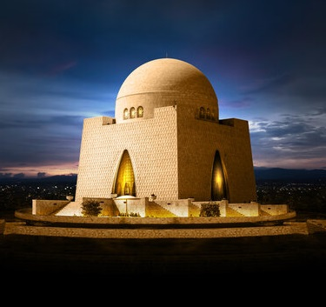­**Quaid -E- Azam Mausoleum**

Gleaming white in the heart of Karachi, Quaid-e-Azam's Mausoleum stands as a beacon of Pakistan's history and hope.

**History**

A symbol of Pakistan's birth, Quaid-e-Azam's Mausoleum rose from years of debate to become a modern landmark in Karachi.